Increased efficiency in the low-mid-range is obtained with a stiffer frame
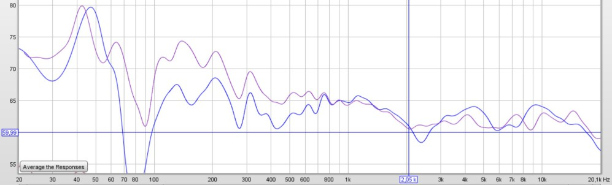
This measurement shows in-room farfield magnitude vs frequency with blue-left speaker before and red-right speaker after re-makeover.
Admittedly, I was not prepared for a significant efficiency gain. I was baffled so to say. There are unfortunately, there are few measurements allowing to compare before and after re-makeover.
Transient properties
The question is where this energy comes from? In the factory version, plenty of energy stored in the frame. The following graph shows energy storage where the green waterfall is factory version and the purple is after stiffer frames are applied:
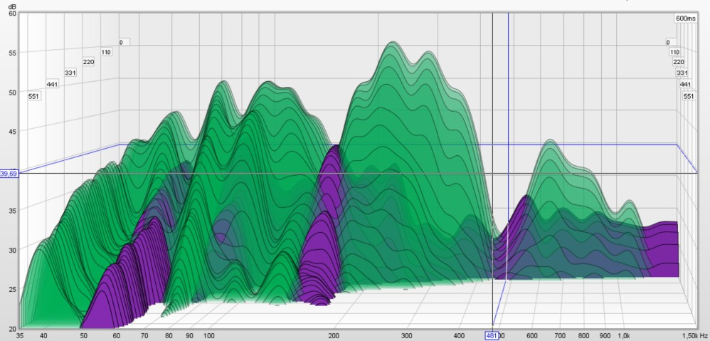
The graph illustrates accelerometer measurement in a point of the upper edge of the frame on the bass element side. The accelerometer, tightly coupled to the frame, should very little be affected by the room modes.
Wherever you put the accelerometer probe at the frame, the similar resonant behavior occurs, Resonances are well spread and mainly below 1kHz.
Energy storage comes in the form of local resonances before energy is converted to heat in surrounding air. There is a variation across the large panel frame but the before/after is in average 10dB, meaning a tenfold difference. This means that the frame rattles and vibrates a lot over more than five octaves.
From the graph, we can easily read the stored energy fall with 30dB:
• 440mS equals to 30 cycles at 70Hz
• 300mS equals to 50 cycles at 200Hz
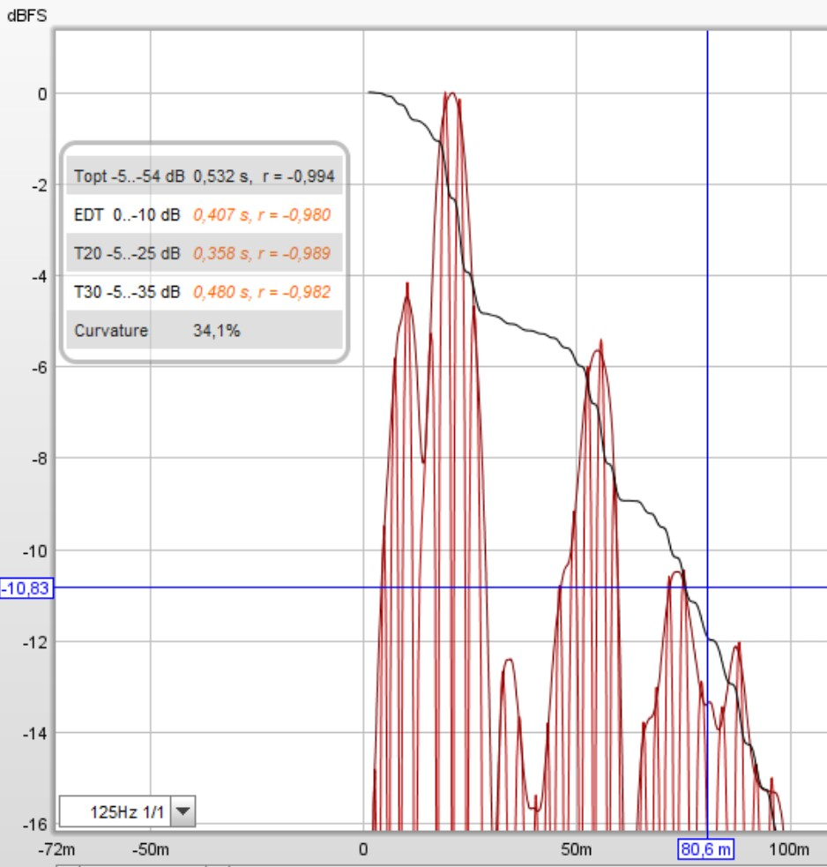
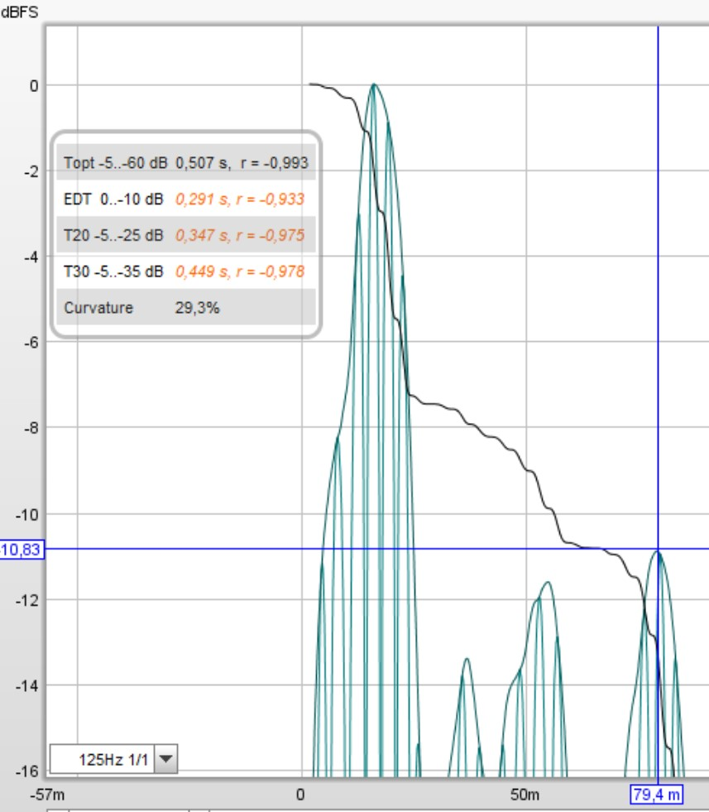
Frame energy storage effect in time-perspective is shown by the in-room impulse measurement below Schroeder frequency filtered at 125Hz 1 octave.
That is a lot of noise generated! Is it heard?
The stiffened frame does ring less, thus is quieter. However, note that this mechanical energy does not directly converts to sound energy. Thus, we cannot know if it's audible.
The back panel is factory-tuned into different resonance regions to spread resonances. The cross-bars installed however rise back panel resonance frequencies so I would advise against.
I hope others feel challenged to research and optimize the resonant behavior.
If true, we have a new fact. The fact is that Magnepan speakers no longer "suffers in bass volume capability". The bass is just hidden as stored energy to be slowly released over time. Such a revelation would be promising many customers. Attenuation of the ribbon tweeters are no longer needed. Longer listening distances with correct tonal balance. Room modes could be treated effective with equalizing.

