In my case, the woofer-mid driver element has been repaired on several occasions during the last 16 years. There are many good advices on those pages, clearly showing an optimal work process. While the recommended adhesives seem not to be available locally, I have used ordinary contact glue. Fortunately, the tweeter elements have never broke. I realize the need to order a spare repair kit
Basically, the stock MG 3.6 speakers are built with a layered approach, a sandwich construction if you will. The three layers are
1 Front vertical trims. These are available in oak or cherry hardwood options
2 Frame of medium dense fibre (MDF) board
3 The two driver elements of steel plate
These are sandwiched together by 3 vertical rows of 4 screws, threaded through the MDF board. The elements are either fastened to the board by screws and staples. If the screws are tightened too much, the wood will break around the contact area.
With each repair cycle the frame, risks to become more lose. The sandwich mechanical bonding is a fundamental stability issue. If sandwich deteriorate, the vibrational damping behavior will change for the worse. The cloth will deteriorate over each cycle of removal and applying and staples.
The real repair issues are the layered design IMO. The production friendliness comes at the price of a cumbersome repair process. When taking apart the speaker, the first impression is at the speaker is designed like a furniture. Lots of cloth which is fixated by plenty of staples to be removed.
New frames
As a long-time patient customer, I may wonder what is there to improve upon? In my case, 16 years of fearless study and practice has accumulated some experiences what tweaks works or not. Beside repeated repair ability, there may be an opportunity to further sound quality enhancement. Could the efficiency, tonal balance, timbre, clarity or imaging or be increased?
This attempt to investigate improvements is reviewed here.
There are many sorurces of inspirations
Generally, in many industries Al-framing are becoming a new standard, such as the building industry windows where aluminum profiles has replaced wood profiles.
Some specific planar speaker attempts are exciting, just to mention a few - The Frankenpan saga, Danny Richie neo-10 neo-3 Force Line Array 1, Alsyvox, Carver ALS Extrusion AL-profile, Eminent Technology ET-8 and Piega Master line source
Actually, Magnepan MG 3.7 are now using such anodized profiles for the trim element. So, why not go all the way to eliminate the old and irreparable MDF board to develop a general purpose AL profile?
MG 3.6 re-make over new frames
Thus, the sandwich principle is kept. The layers are
1 Standard aluminum profiles tightly clamped to the frame
2 Distance material consisting of blasting sand, contained within the profiles
3 The two driver elements of steel plate
Those materials form a stiff and inert bond. Practically this means a sandwich which are not taken apart when there is a future element repair needed.
The environmental impact of sunlight and temperature changes are considered.
- The elements are protected from sunrays by a speaker cloth in the front. The back is completely open.
- The expansion of materials differs with changing temperature. Any issues are avoided by selecting materials of similar temperature coefficients. A temperature rise of 10 Celsius degrees means an expansion difference of 0,17mm between al and steel over the full length.
The key original dimensions must be kept to preserve the speaker acoustic properties.
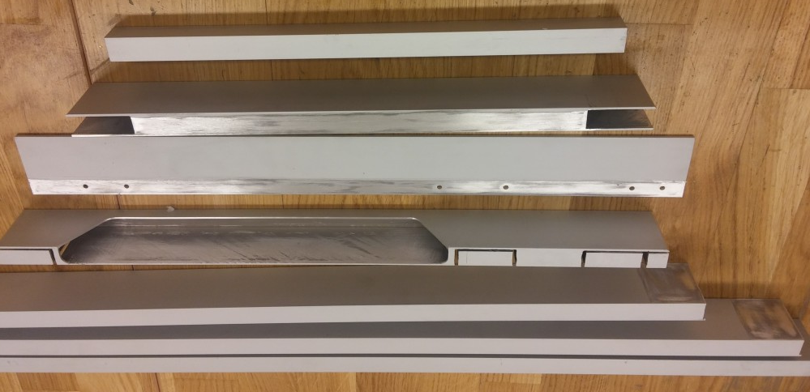
Each speaker has two frames for low-mid and for tweeter element which are decoupled. The frames are mounted on a heavy soapstone platform, decoupled from the floor by Rollerblocks.
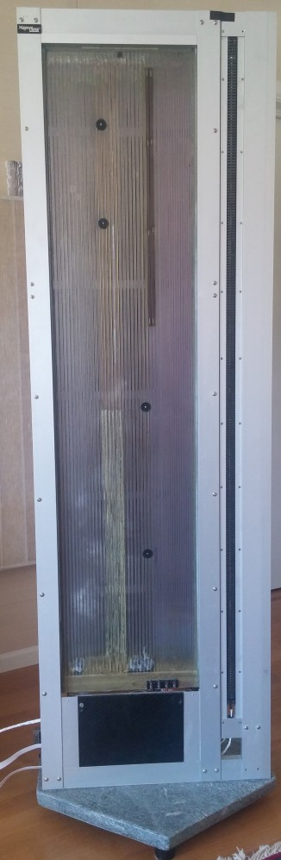
The low-mid range element is clamped to the frame and the tweeter is mounted with screws. The back panel is reinforced with iron rods.
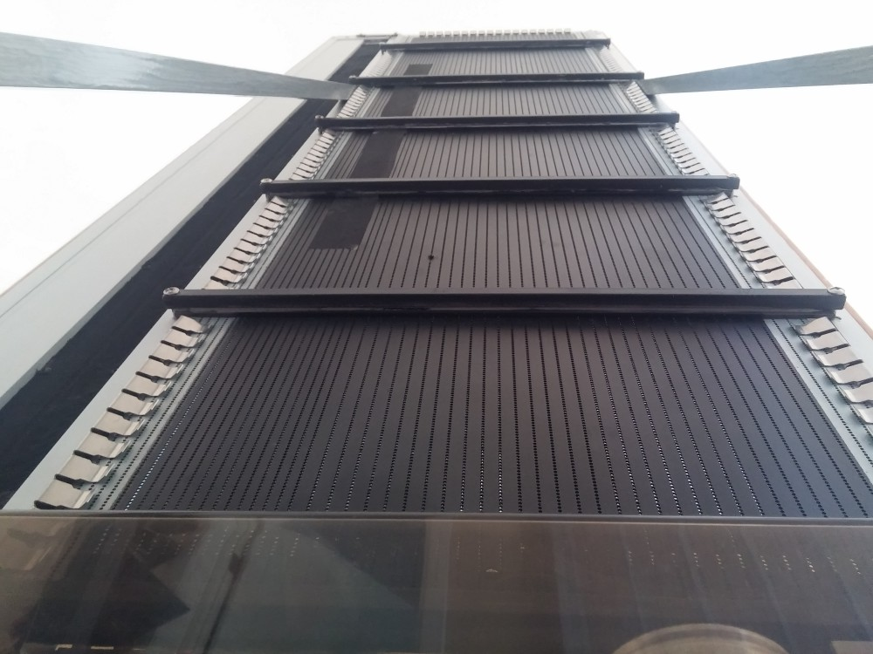

The details:
The frame consists of standard extruded anodized rectangular profiles with dimensions 50 * 20 * 2 mm. The frame joints in each corner is calc-ed, meaning there is an overlap. Each joint is fixated by metal glue and threaded screw.

