The MG 3.6 drivers for woofer, mid-range and tweeter are not flat from dc to light and must be equalized over the frequency range for which they are to be used.

• Thus, an equalizer block is provided in each channel. Gain/attenuation is adjustable to account for differences in driver sensitivity.
• Drivers have a low frequency cutoff frequency and are high-pass filters by design. The low frequency behavior can be equalized to a certain extent, but the high-pass nature remains, which causes a leading phase shift.
• The lowpass filter sections in woofer and mid-range channels may also need modification, as the drivers have a strong resonance.
• Drivers have a strong resonance and irregular frequency response above the filter cutoff frequency. The target is always the correct crossover filter acoustic response.

Driver element properties: Woofer
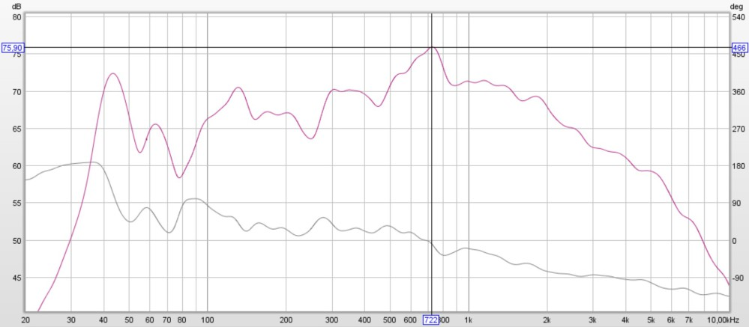

Woofer element in farfield measurement of magnitude and minimum phase 1/6 smoothing

A lot of air is shuffled back and forth between the two sides of the open cabinet. This sets up a strong sound velocity field but our ears only respond to sound pressure and we do not hear it. This is wasteful of cone excursion but the price to pay for natural bass reproduction.
See: http://www.linkwitzlab.com/faq.htm

Frequency response
In the very low frequency region, below the first room-mode, the monopole response gains consistently from pressure buildup compared to a dipole. The range of lowest single octave from 16Hz is filled by subwoofer augmentation.

The woofer element has a fundamental high-Q resonance at 42Hz and 135Hz.

The baffle step sets in at 500Hz before a natural roll-off from 1000Hz.

The element is affected by environmental causes. The wall behind an open baffle speaker, the front wall from the listeners perspective, reflects the rearwards radiated sound which is 180 degrees out-of-phase with the forward radiated sound. The interference between the two leads to progressive cancellation at low frequencies and comb filtering at higher frequencies for steady-state sounds. A dipole parallel to the front wall will be affected mostly by the front wall reflection, but the null will be very deep. If the speaker is angled in, it will start to illuminate the side wall and you'll get two reflections with shallower nulls. Single panel dipoles are generally use with toe in so the same rule applies as to monopoles, you want to split the difference between front and side walls to reduce the null. The optimal distance is about ¼ wavelength of the 45Hz peak equals to 1.9m. At this distance the peak will be cancelled or subdued by the back-wave. Here, a dip around 80-90Hz occurs due to proximity to the back wall. In other rooms where wider flexibility is allowed, the backwall distance could be increased.

Dipoles small rooms suffers from excitation of room modes like monopoles, but only in one of the dimensions. The bass in most practical cases can be made fairly flat and hence quite well timed, bell-shaped resonances or anti-resonances with adjustable centre frequency and "Q" with minimum-phase equalizing. Digital equalizing units are far more effective than acoustic bass treatment.
Read more: http://www.regonaudio.com/The%20GREAT%20Divide.html

Attempts to treat the room with absorbers will make only marginal differences unless very many absorbers or large absorbing surfaces are used. It is best to attenuate peaks in the bass response with parametric equalization. Holes in the response cannot be filled in
Read more: http://www.linkwitzlab.com/rooms.htm

Directionality
The driver itself, due to its width, becomes more directional with increasing frequency, it also illuminates the panel edge with less strength, which then reduces response irregularities caused by diffraction. This comes into play when the effective width becomes larger than 1/3 of a wavelength. As the element width is around 22cm, directionality increases above 500 Hz.

Clarity
The bass panel has a secondary resonance in the 800-1000Hz range that you don't want to excite. It really muddies things up. The bass panel is very short on detail in the upper reaches, so would add a layer of fuzz even into the upper midrange, if it is not curtailed by equalization or a steeper crossover than 1st order.

Woofer element equalization
Since the wavelength is large compared to the room and treating them as specular reflections doesn't really work.
Specifically
• Fundamental high-Q resonance at 42Hz and 135Hz are decapitated by corresponding notch filters
• The deep crevasse-hole close to 80Hz is left untouched
• The baffle step and resonance are flattened by a low shelf and a notch filter.
• The standing wave is in itself is electro-acoustic system induced resonance and thus store energy, which is then gradually released. This is a linear phenomenon and in theory can always be corrected with equalizing filters.

Driver element properties - Mid-range

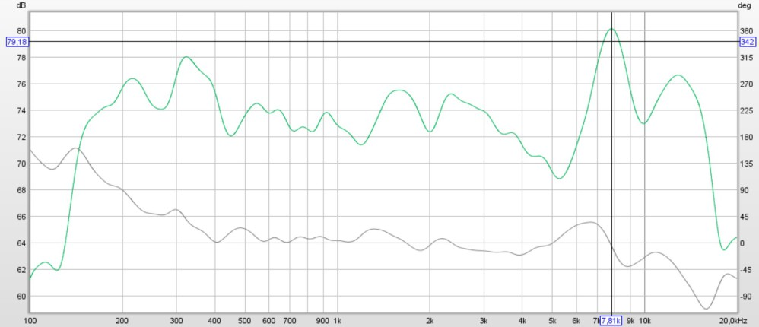

Mid-range element in farfield measurement of magnitude and minimum phase. 1/6 smoothing

Frequency Response
The mid-range has a high-pass second order acoustic roll-off.
The mid-range element has a fundamental resonance just above 200Hz and a high-Q "diaphragm breakup" at 7500Hz which inhibits the natural roll-off. The mid is less affected by room modes. Here is a probable specific room-mode peak just above 300Hz.

Diffraction effects.
The driver radiates towards the front and with opposite polarity towards the back. A pressure increase in front is associated with a pressure decrease in back of the baffle. Observing again the response to a stepwise increase in pressure at some on-axis distance in front of the baffle, we see the initial pressure increase, which drops to 1/2 when the edge diffracted front side wave arrives. At the same time, we also receive from the backside of the baffle that 1/2 portion of the wave, which was diffracted around the baffle edge into the frontal hemisphere. The 1/2 of the backside wave is of opposite polarity to the front wave and together with the front edge diffraction cancels the front wave completely.
The "baffle step", the transition from 4p to 2p-space radiation, occurs at higher frequency for a narrower baffle. This keeps the power response more uniform over a wider frequency range and the spectral signature of any reflection more like the on-axis response. Large radius or wide chamfered edges smooth the high frequency response on-axis and off-axis.
The effect of baffle diffraction can be observed and measured in the frequency domain as on-axis and off-axis frequency response irregularity. Diffraction effects can be seen most easily in the time and amplitude response.

Ultimately, it is the on-axis and off-axis frequency response of the equalized speaker that tells how well diffraction effects have been integrated into the design.
Read more: http://www.linkwitzlab.com/diffraction.htm

Baffle step due to the element location asymmetric location is the probable cause of two series of ripples. First peak occurs at 900, followed by 1600, 2400 and 3700Hz.

Directionality
The driver itself, due to its width, becomes more directional with increasing frequency, it also illuminates the panel edge with less strength, which then reduces response irregularities caused by diffraction. This comes into play when the effective width becomes larger than 1/3 of a wavelength. As the width is around 3" or 7,5cm, directionality increases above 1500 Hz.

Clarity
The mid-range drivers becomes fuzzy and slow above 2Khz as reported on those pages.

Mid-range element equalization
Digital IIR filters are used
• The resonance peak are severed by a high-Q notch filter.
• The breakup resonance can as an alternative be severed by a passive electric notch filter.
Diffraction effects the mid-range driver only mildly..

Driver element properties - Tweeter

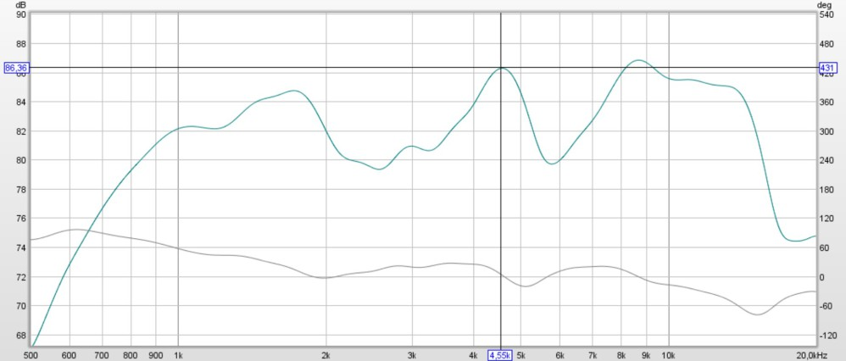
Tweeter element nearfield measurement of magnitude and minimum phase 1/6 smoothing with manufacturer's crossover and stock front panel

Tweeter frequency response
The response shows two shallow dips 3000 and 6000Hz region.
Baffle step peaks are hard to identify.

Tweeter element equalization
The re-makeover of frame and front allows for a slightly changed geometry.
• While distance between mid-range vertical centerpoint and tweeter is kept,
• The tweeter is mounted in flush with the panel by moving it forward about 3mm.
• The asymmetric tweeter cavity depth is reduced from 20 to 6 mm.

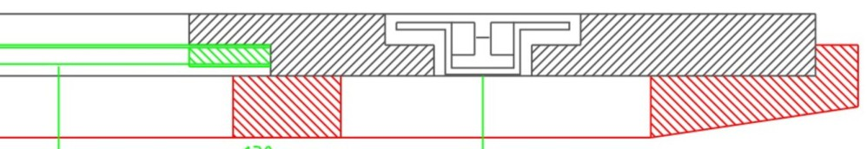

MG 3.6 stock front panel cross-section on the tweeter side

Designers workbench
Active crossovers have a long and convincing list of technical advantages. Douglas Self in his book Active crossovers lists 22 very real advantages compared to 9 for passive crossovers. For me as the designer, active crossover/equalizer, combined with multi-amping gives a much greater freedom and control while not having to deal with the interaction between driver impedance and passive filter network. With a digital workbench capable of four stereo channels each providing 10 Infinite Impulse response (IIR) filters, I can closely simulate all the known analog filter functions, and also have their associated non-linear phase shifts. The frequency response of a given IIR filter, can be easily changed by reprogramming its coefficients, allowing an instant listening to the results.

For all measurement & correction in magnitude, frequency, time, phase and polarity dimensions, I use some basic equipment:
• LinearX microphone
• Xtrinsic Digital Accelerometer MMA8451Q 3-Axis, 14-bit/8-bit
• AUREON XFIRE8 HD soundcard
• Room EQ Wizard, REW software
• Eclipse Audio FIR Designer
• MiniDSP MiniSHARC board with MiniSHARC 4 x 96k plug-in
https://www.minidsp.com/forum/diy-hifi-projects/13218-minisharc-dsp-soekris-dac-4-x-8-pre-amp

