In a domestic living the music listening easily becomes a social interaction activity. In such an environment, the spousal acceptance factor is a frequent topic.
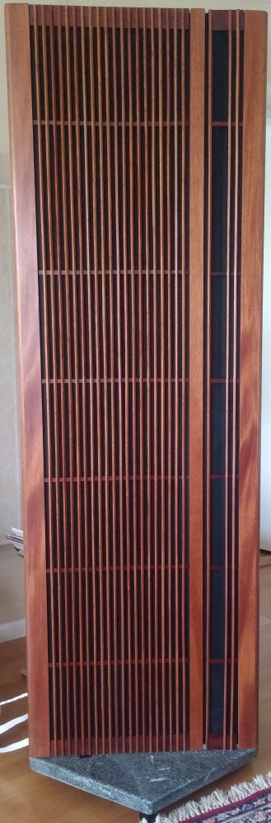
In my case, the re-make over was a fitting moment to re-consider the speaker outer appearance. As the speakers now has reached an age of 16 years. The manufacturer style of "Minnesota prudence" it is replaced by some time-less and elegant outfit, I feel.
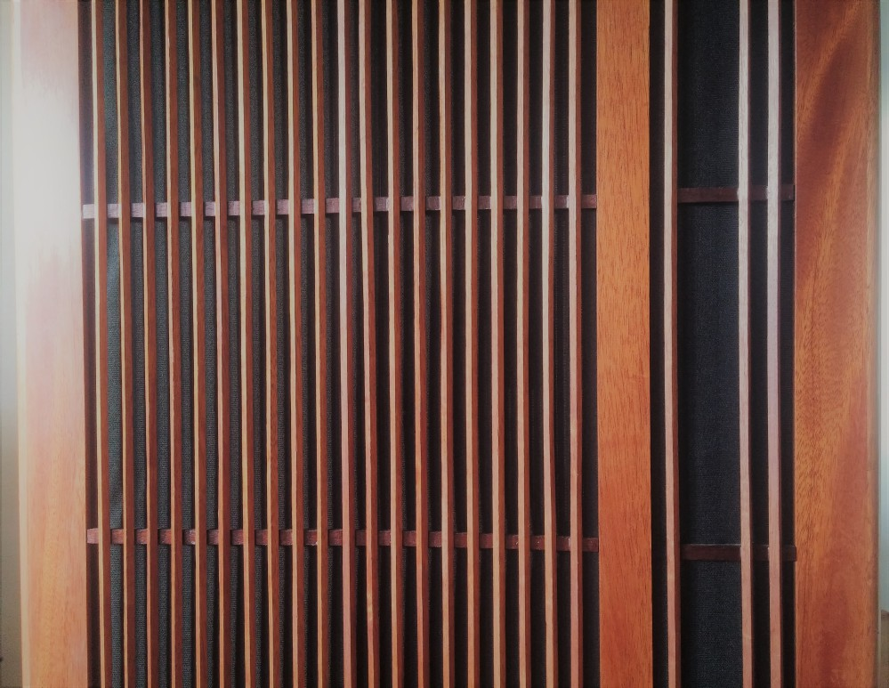
The wooden grill is made from several parts. The edges, trellis and mid-divider are all easily to remove without tools. Permanent-magnets has been used to hold the thin-layered front appearance in place. Material used is all mahogany. Fine-dimension lists has been further cut into 6 x 6 mm as the base of the raster. The raster has no diffraction impact within the frequency range up to about 12kHz. The inherent cavity is now reduced (from 20 to 6mm) which may reduce early high-frequency reflections.
The cloth is required for protecting the glue from deterioration by direct sunlight. The standard manufacturer cloth could not be re-used due to a number of enlarged screw holes. In the market, there are many extravagant "radio cloth" or "speaker cloth".
The plinth is cut from a heavy soapstone slab, rests on 3 rollerblocks.
The saying "beauty lies in the eye of the beholder" is true. In my eye, the outfit is a celebration of the many years of music enjoyment these speaker have provided.

