At the time of release, the MG3.6 where acclaimed as a great bargain (Stereophile, HT Review).
IMO, today a used MG3.6 after re-makeover is such a bargain! Personally, the clarity this speaker could provide, where sufficient to decide. Over the years, the speakers have reached a summit, from where no journey will to improvement. So, let me conclude the technical changes and their effects.
• The frames must be very rigid and non-resonant. The distributed bass resonance back-plate should be drained and absorbed locally and cannot be drained to ground. The frame and back-plate form a compound, thereby firmly coupled (i.e. low resistance). Stiffening of the frames allows for a higher efficiency in the low-to mid-range with about 3-5dB us useful in larger rooms and will probably lower risk for delamination.
• Inspection and repair are instantly available as the front is detachable without tools.
A DSP-based 3- or 4-way "workbench" allows to correct individual driver elements from inherent flaws through the full bandwith. Most peaks are min-phase and till leave no side-effects.
• .Severing the underdamped bass alignment excessive peak would improve low-level transient behaviour as well (Mike Gough, Senior Product Manager, B&W Loudspeakers Ltd.)
• Severing secondary peaks and baffle-step peaks would further improve Timbre.
• For the realization of crossovers, the workbench speed up workflow while reducing potentially expensive mistakes dramatically.
Let me revise the Appropriate goals for sound fidelity from the Linkwitz lab pages and see is these where fulfilled.
The overall goals suggested are basicly concerning room-speaker interaction.
1. The speakers must be placed so that reflections are delayed relative to the direct sound. In our domestic living room, the geometry put constrains to required distances. The speaker properties of being a dipole line source limits dispersion to most critical reflection surfaces as side-walls respectively floor-and roof.
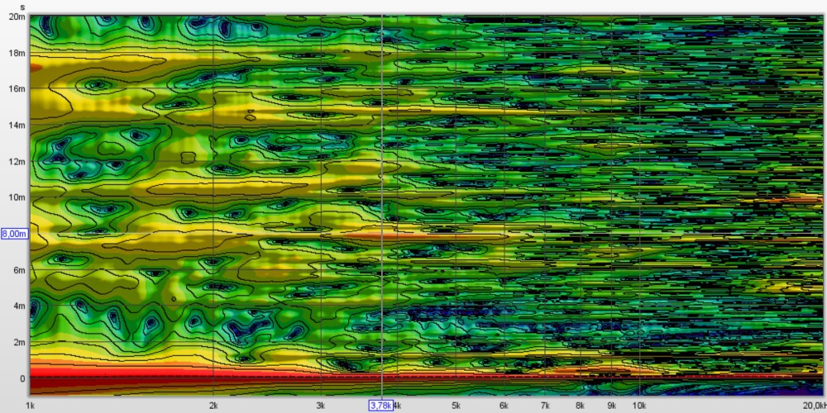
Spectrogram showing room reflection from listening seat position within the first critical 20mS time window. Note the only strong reflection -6dB point at 8mS with limited bandwidth is probably unheard.
2. The speakers must be free from spurious resonant radiation and their off-axis radiation must follow their on-axis frequency response for the reverberant sound to be neutral. This speaker hosts no resonant cavities to store energy.
3. The polar radiation pattern must be essentially either omni-directional, cardioid or dipolar, aiming for constant directivity. '
4. The wide front- and back full-range distribution of near flat amplitude will illuminate the room uniformly to create a lively ambience in an non-overly damped room with 60dB decay between 500 and 200mS.
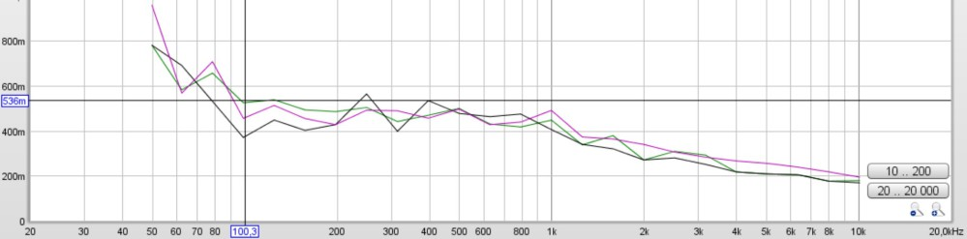

Decay T20 black, T30 red Topt 5-59dB green
A close-up 3D view of decay time within 200mS
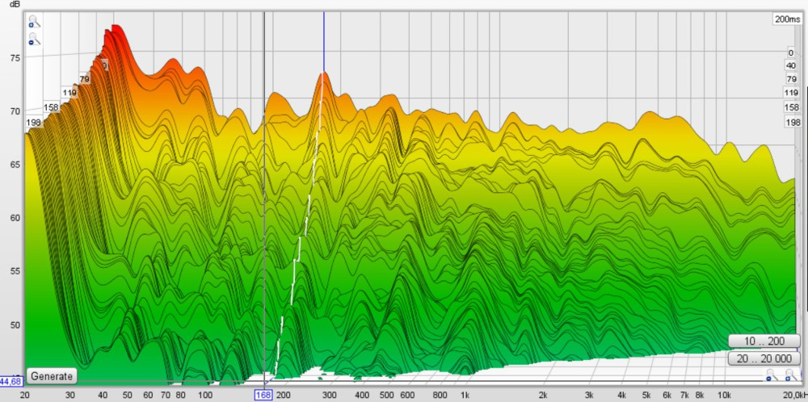
The Waterfall shows a steady room fundamental at 20Hz hearing threshold and a narrow peak at 168Hz. The decay pattern is very orderly.
5. The speakers must be acoustically small, yet capable of realistic volume levels at low non-linear distortion. While the sheer size will make those behemoths are efficient intruders into a living room, they appear as acoustically small. Being essentially a line-source speaker , Vertical height of the sound stage adds to its realism. They are "best when listened to close-up like giant headphones."
Read more: http://www.linkwitzlab.com/frontiers.htm, http://www.linkwitzlab.com/The_Magic/The_Magic.htm
In specific measurable terms this means:
Amplitude/frequency response variations within the range of 40-16 000Hz are tolerated within 4dB in an anechoic environment. In an ambient room, the power response is different.
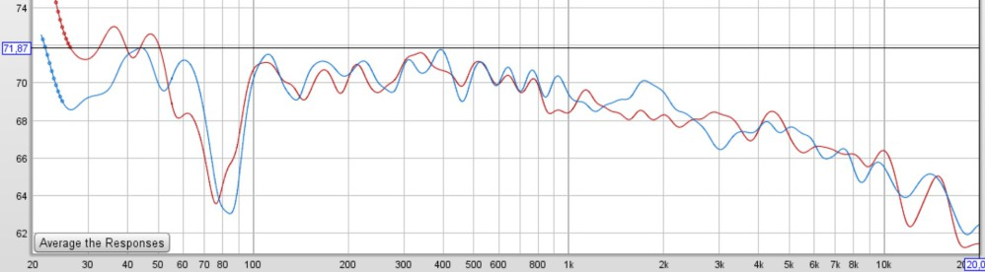
The amplitude response is within target curve and the tolerance with exception of the front-wall cancellation in 90Hz range. Resolution is 6dB/octave.
Difference between the set of stereo speakers in anechoic conditions requires a tolerance of 0,5dB. In the power response above, the deviation between the pair do not exceed 2db within the range.
Non-linear distortion cannot be measured with the actual equipment. The harmonic distortion graph shows that distortion is below 0,5% in the important range of 130-2600Hz and below 1% from above 100Hz, mostly below the equipment noise flor and well with-in the tolerance level.

Transient fidelity means how well the speaker respond to an impulse.
The on-set
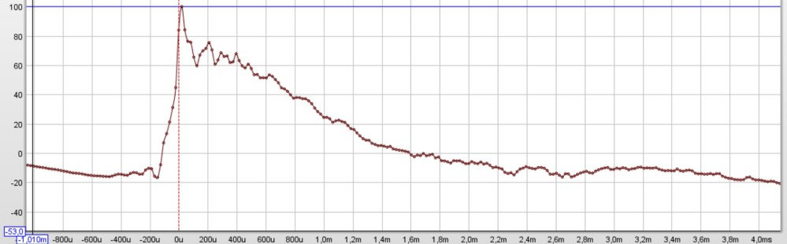
Please note that the initial impulse shape is directly dependent on the speaker toe-in angle.
As there are few speakers in the market for transient fidelity, no criteria's are available.
"Of the speakers I have measured for Stereophile, only about 10-models from Quad, Thiel, Dunlavy, Spica, and Vandersteen-have step responses this good."
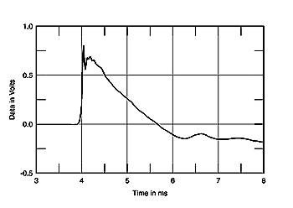
The measurement shows Decay time for reduction to a level of 1/e to 0,37 or output level. Tolerance level is 5 cycles.
The measured results shows that less than 7 cycles are required in the range from 60-500Hz and 5 cycles between 100-4000H and finally 8 cycles in the range around 8000Hz.
Most importantly, time delay difference between speakers is an effect or min-phase variations.
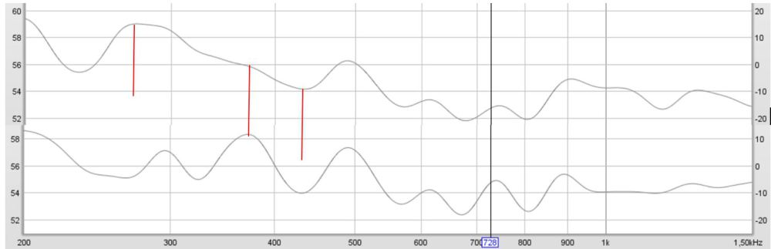
The above graph shows the min-phase variations between the speaker pair. The phase difference is less than 12 degrees above 350Hz within the ITD range between Shroeder frequency and 800/1600Hz.
Read more of Tolerance levels accepted: http://www.linkwitzlab.com/Attributes_Of_Linear_Phase_Loudspeakers.pdf
Stretched goals
While my journey has reach a summit, we take a rest to enjoy the view and to look for other peaks in the far distant. While pondering, one can think of improvements, if any, allowing to stretch the above goals. Please feel invited to visit this spot!
Thanks for the attention and comments!

